# Project Proposal

# 

# Rupinder Singh

### Student ID:3152907

1)      Project Goal

2)      Project Objectives

3)      Project Scope

4)      Project Deliverable

5)      Resources – what all resources are required to complete this project

6)      Project Milestone

7)      Project Schedule.

# Project Introduction and Goal

Bikram wants a website for his school in which students can enrol. He also wants an admin panel in which he can login and see the details of student that are enrolled. He wants to edit and add the information of students that are enrolled

# Client Details

|  |  |
| --- | --- |
| **NAME** | Bikram Singh |
| **CONTACT** | .0213275423 |
| **ADDRESS** | 74 Russell Road, Manurewa, Auckland |
| **E-MAIL** | bs@gmail.com |

# Project Description

## Project Need

An online website for students that they can use to enrol. A Page in which student entered their credential. A login system which Bikram and his employees will use. An admin panel in which the person that is logged in can edit the information about the students that are enrolled.

## Goals and Objectives

The goal of this website is to enrol the students in the program. Students can add their information. Once the student is added the admin can add other information about the student that is enrolled.

The website allows following features: -

* Students can add their credentials.
* Admin can login by using username and password.
* Admin can add additional information to the student that are already enrolled.

## Target Audience

The first target audience are the student that want to enrol. Students can add their details and click submit button. The second audience is the admin, Admin can login using the given password and username and add the additional information of the students. The can also check the courses that available in the college.

## Out of Scope: -

Can put the function of filter the student by course

Can add the gallery page that will show the building of the campus.

## Languages used: -

* .Net framework
* C Sharp
* ASP.net
* Bootstrap
* MYSQL

## Project Deliverable: -

## The wireframe of the project

## Home Page

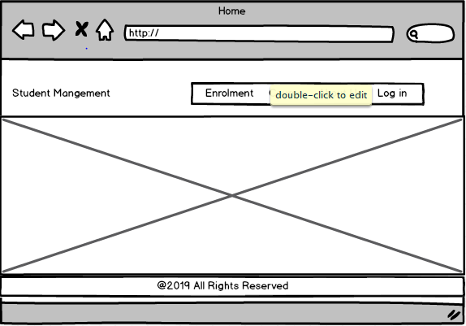

# Enrolment Page

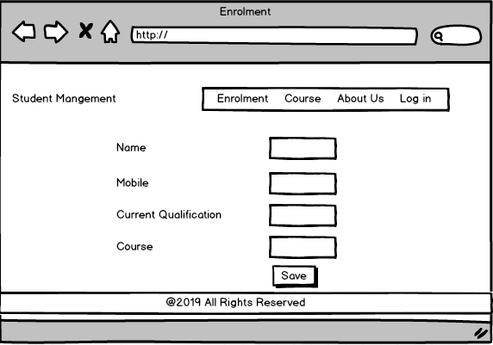

# Course Page

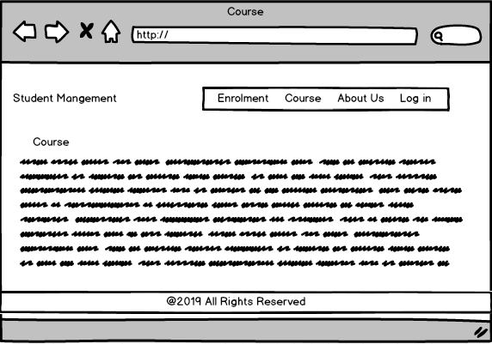

# About Page

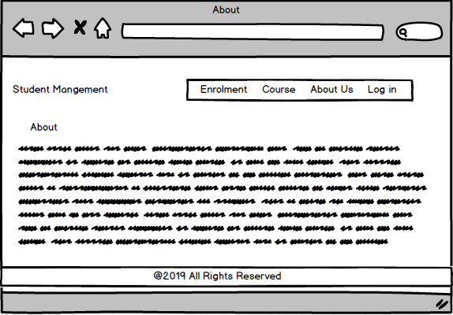

# Login Page

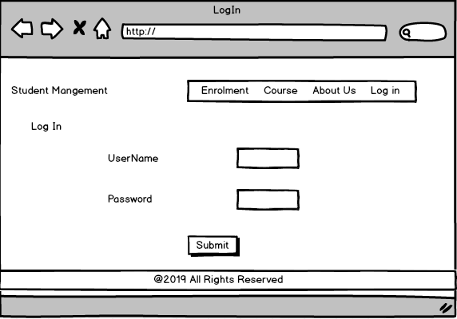

# Student Detail Page

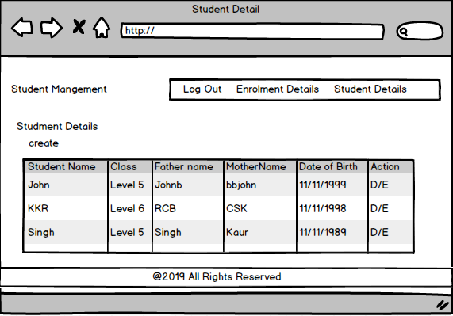

# Enrolment Detail Page

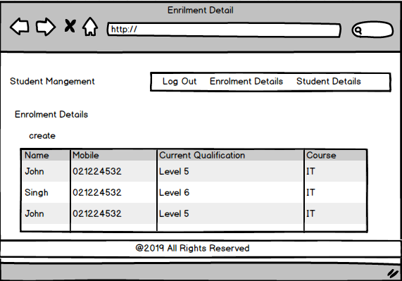

## Quality Plan: -

|  |  |  |  |  |  |
| --- | --- | --- | --- | --- | --- |
| Step NO | Test Step | Input Data | Expected Result | Actual Result | Test Step Result |
| 1 | Edit button of student table | Singh | Data should edit from the table | As Expected | Pass |
| 2 | Delete button of student table | Vicky | Data should delete from the table | As Expected | Pass |
| 3 | Enrolment data table | Paul | Enrolment data should add to the enrolment table | As Expected | Pass |
| 4 | Login submit button | admin | Submit button in login form should work properly | As Expected | Pass |
| 5 | Student create button | Singh | Student detail should add to student table | As Expected | Pass |
| 6 | Back button | back | After clicking on back last page should open | As Expected | Pass |

# Documentation of project.

# Home Page.

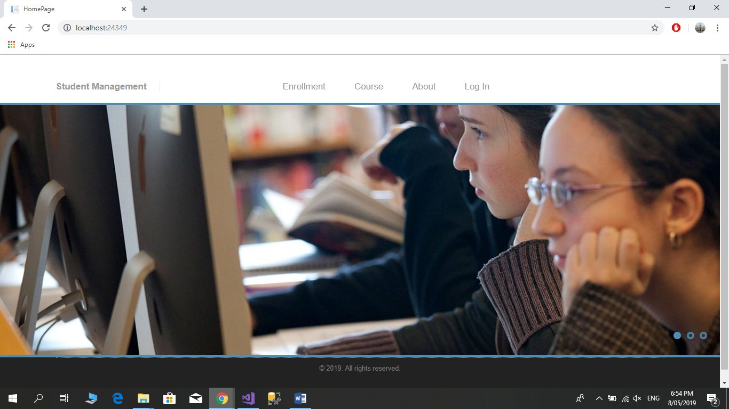

### As we start from the home page, it is fully functional and responsive. It is further attached with four pages which are enrolment, course, about and login respectively. The background and the footer are given for a professional look.

# Enrolment Page.

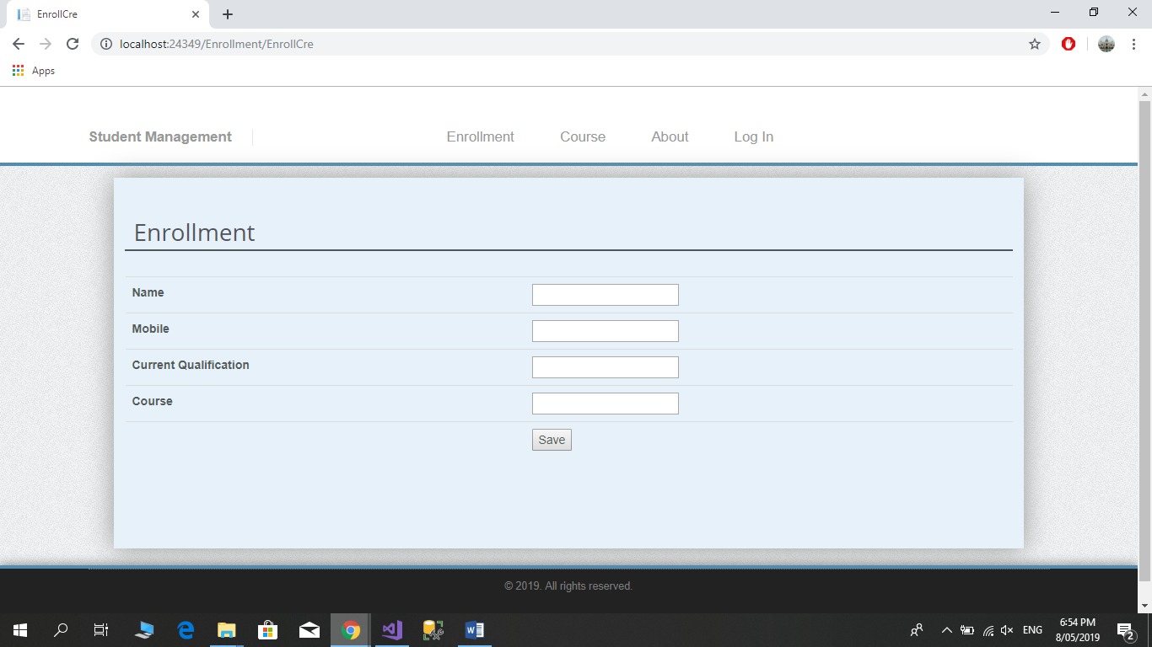

### In the enrolment page a form is asked to fill the details which are the viewer’s name, mobile, current qualification and course. Which is must require for the enrolment. A good design is provided.

# Course Page.

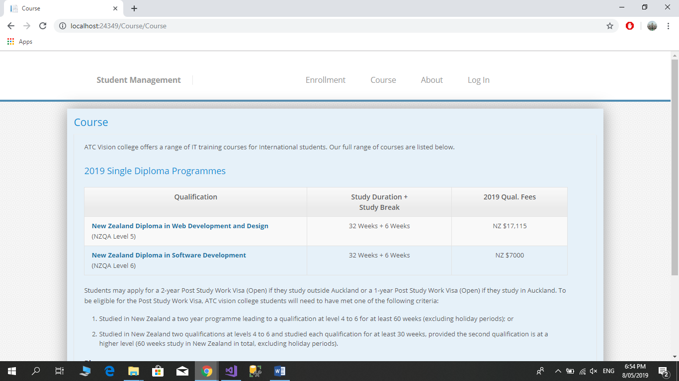

### As we come to the course page, the major details of the different courses are mentioned briefly. A viewer selects the course before applying his/her enrolment. The structure of the course and its fees is also provided.

# About Page.

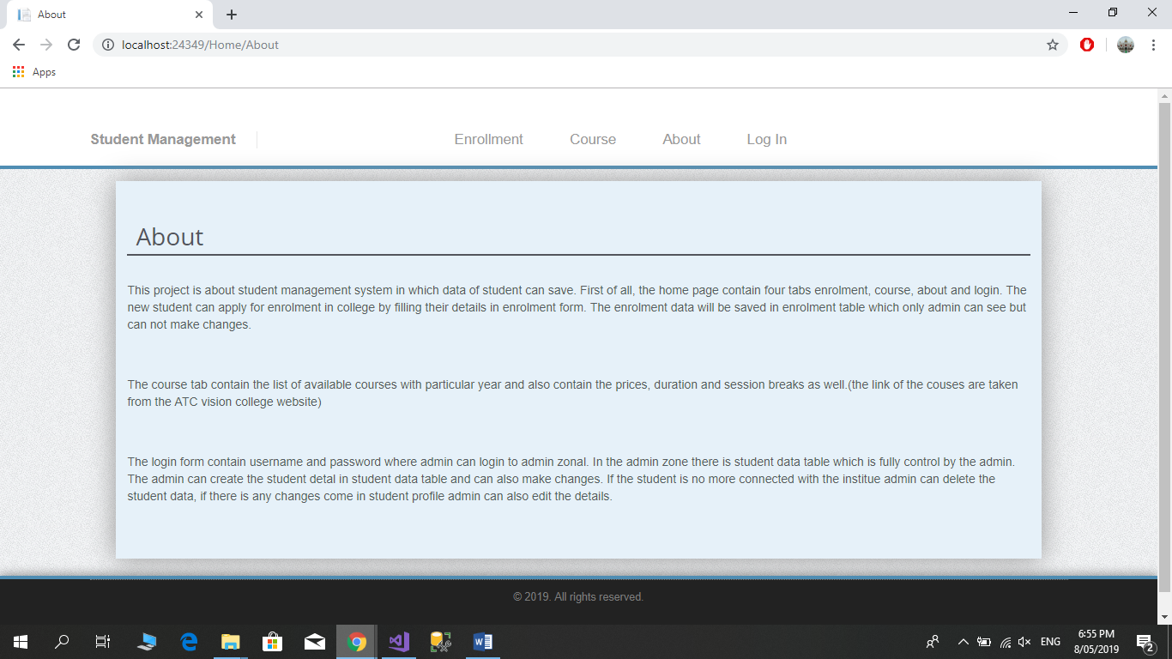

### In the about page all the minor details of the project is mentioned that how the project ids worked.

# Login Page.

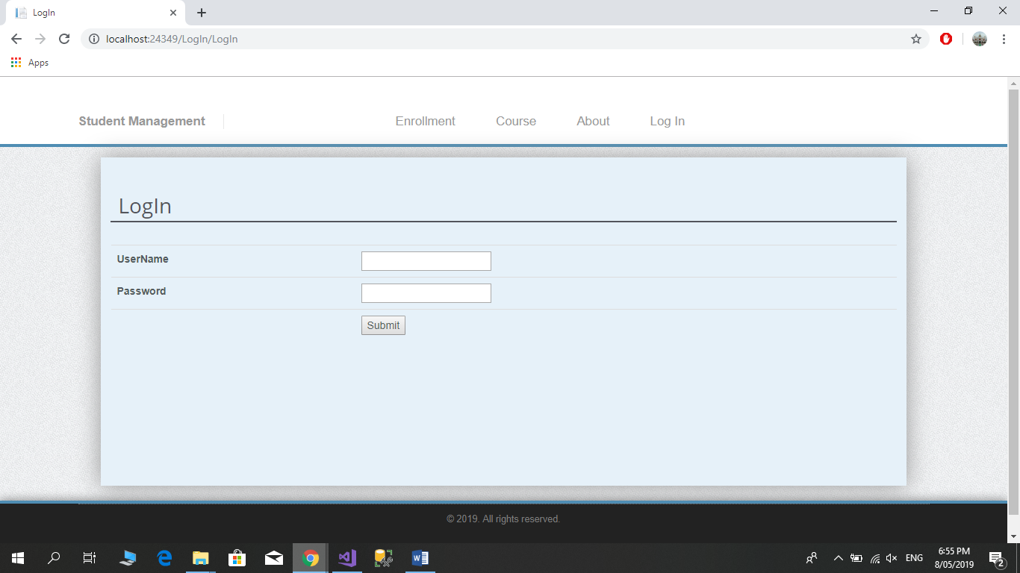

### Login page carry a login form which further goes to admin panel after submitting the username and the password.

# Student Details Create Page.

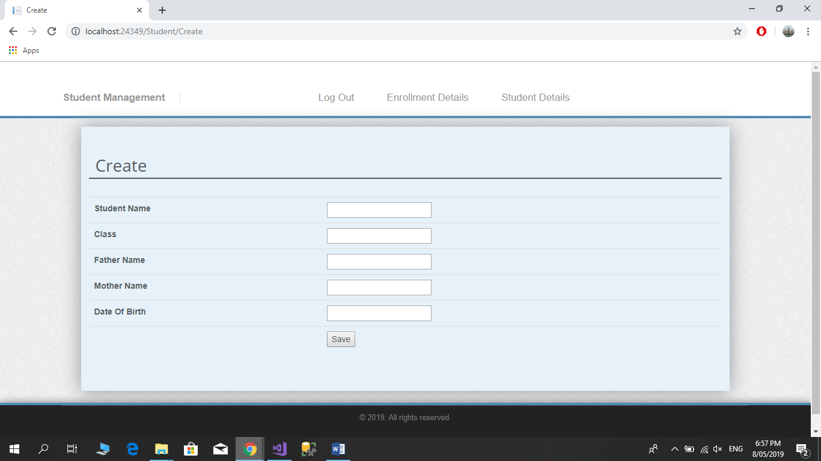

### In this page admin can add the further details of the student which are enrolled for the college admission. If there is any mistake then admin can also change the details by using edit feature.

# Student Details Table Page.

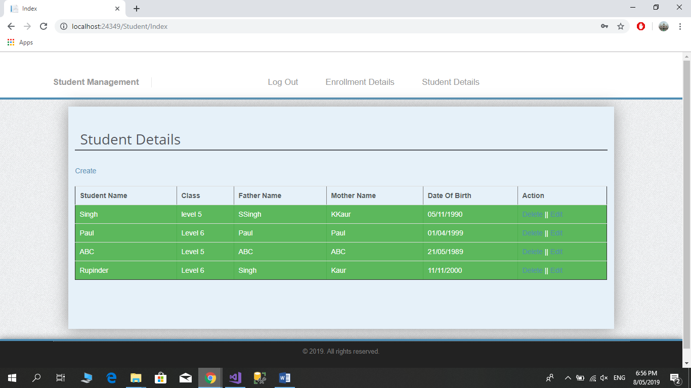

### This page shown the details of the student who are enrolled, and admin add his/her further details like date of birth, father’s name etc. The admin can also make changes in the student details and can delete if student no more connected with the college. There two buttons available for edit and delete for making changes.

# Enrolment Details Table Page.

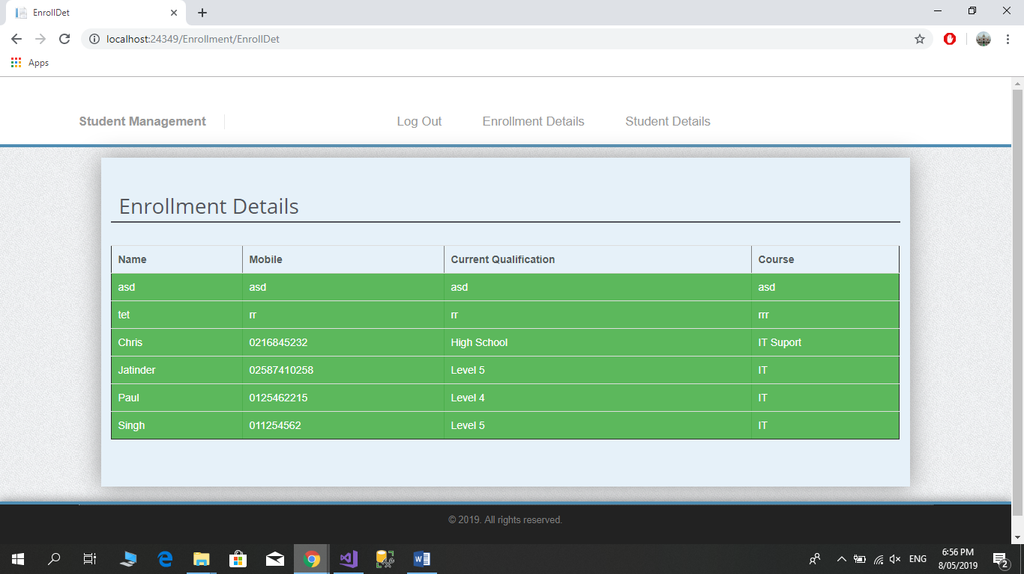

### The enrolment table contains the information of the student who applied for enrolment and this data can only admin can see.

## Project executive summary: -

**Hardware: -**

* Windows 10
* Intel core processor i5
* 8GB RAM

**Software: -**

* Visual Studio 2017
* Microsoft SQL

**Languages: -**

* C Sharp
* jQuery
* ASP.Net
* SQL

## Resources: -

Requirements Required to complete this project are as follow:

* PC must have RAM of 8GB.
* Windows used should be Windows 10.
* At least Intel i5 Processor should be used.
* Visual Studio 2017 is Required for the coding.
* Microsoft SQL is required for establishing the database and for the connection between visual studio and database.
* C#, jQuery, bootstrap, HTML, NETFramwork, ASP, all of them should be used.

## Project Milestone: -

|  |  |
| --- | --- |
| **WORK** | **DAY** |
| Database | 12 April to 14 April |
| Controller | 15 April to 20 April |
| Front End | 20 April to 22 April |
| Back End Coding | 23 April to 28 April |
| Documentation | 30 April to 30 April |

## Project Schedule: -

|  |  |
| --- | --- |
| **WORK** | **HOURS** |
| **Database** | **3 hours** |
| **Controller** | **10 hours** |
| **Front End** | **13hours** |
| **Back End Coding** | **15 hours** |
| **Documentation** | **1 hours** |